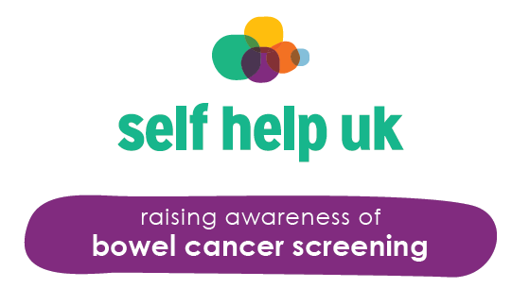

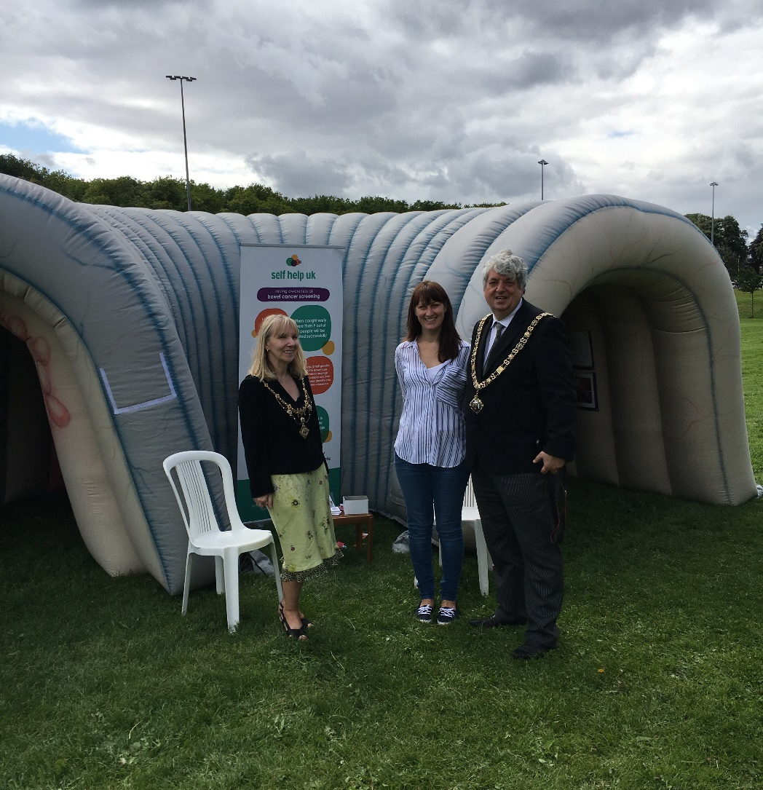

Project Manager – Keeley Cochrane
Early Diagnosis Project - Communications Strategy Evaluation
Nottingham City CCG commissioned The Early Diagnosis Project with Self Help UK with the ambition of increasing the uptake of the Bowel Cancer Screening Programme amongst eligible residents of Nottingham City aged between 60 and 74. As Nottingham has particularly low numbers of engagement with the screening programme; as low as 32% in some areas, the CCG also funded research into the uptake of the screening programme in areas with high BME representation. The report published from this research: “Increasing the uptake of Bowel Cancer Screening in BME communities in Nottingham City” was used to focus the activities of the Early Intervention Project.

Project Objectives
The key objectives of the Early Intervention Project were:
- To increase the awareness of bowel cancer amongst the residents of Nottingham City
- To raise awareness of the importance and success of Early Diagnosis
- To increase uptake of the Bowel Cancer Screening Programme
The service met these objectives by:
- Targeting the areas in Nottingham City with BCS uptake of less than 50% - these areas typically have a higher proportion of people from BME communities and are areas of high deprivation.
- Raising community awareness and education in these areas of bowel cancer and its incidence rate.
- Using a personal approach to reach communities, as identified in the CCG commissioned research.
- Raising the understanding of ‘screening for prevention’ and normalising ‘screening to stay healthy’.
- Tackling ‘fear of results’ as a barrier to completing the FOBT by raising awareness that 97% of bowel cancers can be successfully treated if caught early. Dispel the myth that bowel cancer is always fatal.
- Focusing on language/literacy barriers faced by non-English speakers or those with English as secondary language, or those that cannot access written word.

Key Achievements
The Early Diagnosis project used a mixed marketing approach to implement the aims of the project. We engaged with the various communities in Nottingham City in a variety of ways, adapting our approach accordingly and the following is a breakdown of the specific achievements.

Activity | Evaluation
Telephone calls to non-responders specific to each GP surgery; focusing on surgeries with uptake of less than 50% | This was a highly successful intervention addressing the pressing theme of “The need for a personalised approach” highlighted in the CCG funded report: “Increasing the uptake of Bowel Cancer Screening in BME communities in Nottingham City”. Over 16 surgeries within Nottingham city were visited with over 1,300 non-responders being personally contacted. The vast majority of these surgeries were in areas of high deprivation and in surgeries with an uptake rate of less than 50%, however, as a small number of GPs or practice managers in surgeries where they were keen to further increase their uptake contacted the service, they were also visited.  The phone calls allowed patients the opportunity to discuss any difficulties or barriers they had encountered in completing the test, as well as the opportunity to resolve any concerns around the process. As this was done on an individual basis, the calls could be tailored in a culturally sensitive manner, taking peoples preferences into account. This was highlighted by the frequency of conversations in which people disclosed that they had thrown away their kit because the instructions were written in a language that they could not read. People were happy to be sent out a replacement kit in their chosen language to enable them to participate once they understood the reason for the kit being sent out.  The phone calls highlighted the minimal awareness of both bowel cancer symptoms and the importance of early diagnosis amongst the older age group. It provided the opportunity to dispel many myths and fears whilst promoting the public health message of ‘screening for healthy people’.  As Appendix 1 shows, of the 1,364 patients contacted, 57% of patients requested to have a replacement kit sent out. There were a further 5% of patients who still had their kits at home and simply needed some encouragement or further information to go on to complete them. Data from the screening hub expressed that of the 57% of patients requesting a replacement kit 30.8% went on to complete and return their screening tests.
Take inflatable colon to events/festivals/carnivals/health days/etc. | The inflatable colon was a particularly eye catching piece of equipment which helped to open up conversations that can often be viewed as being taboo. As it is such a memorable resource, there were often requests made for the service to attend at festivals/events. By being present at family events, we were better able to reach people who may not have otherwise stopped for a discussion, as their children/grandchildren were keen to interact with the colon. Events had the added benefit of frequently having male present with their partners; both the report and experience gained through telephone contact with non-responders showed that “men identified their wives and partners as being a big influence on their engagement with health services”. This aided conversations that may not have otherwise taken place.  It was particularly useful at events to have a telephone with which to contact the Eastern Screening Hub directly to request replacement kits for eligible citizens of Nottingham city. Whilst exact figures are not available for this intervention, an estimated 50 replacement kits were requested in this manner.  The project also had branding designed which was imported onto giveaways to hand out at events. Both pens and hand sanitizers stating the successes of early diagnosis helped to draw people over to the stall and enabled us to get information across in a more relaxed manner. Leaflets, posters and banners were also utilised to draw attention at events and these were designed to be culturally relevant in line with the report’s findings. (See Appendix 2)
Interview/ readout/ advertisement on culturally relevant radio shows during Bowel Cancer awareness month (April) | In order to normalise the message of ‘screening for healthy people” a radio campaign ran during bowel cancer awareness month on Nottingham City’s local radio station Kemet FM. An advert was played out 3 times a day throughout April, which was aimed at raising people’s awareness of bowel cancer symptoms and the importance of completing the FOBT. There were also two live interviews with the Early Diagnosis Project Manager played out during the month on the health section of the programme, which provided the opportunity to promote the positive facts of early diagnosis and break down the stigma of talking about bowel cancer and the screening test. As the report had also highlighted the “The use of family members and other supporters was key to helping people access the right information”, the interviews and adverts provided the opportunity to promote the message of looking out for family and friends by encouraging them to take the test. After hearing the advert, several people contacted the service for more information and to request a new kit be sent out.
Spreads in culturally relevant magazines/newsletters during Bowel Cancer awareness month | During bowel cancer awareness month Mojatu magazine featured a double page spread aimed at raising awareness of bowel cancer and the importance of early diagnosis and the screening test. Mojatu magazine is a community voice magazine based in Nottingham focusing on African and Caribbean communities in the UK and beyond. This article provided the opportunity to reach BAME communities to increase the understanding of bowel cancer and screening.
Hold stall at BAME Roadshows around the city organised by Selfhelp’s BAME Health Outreach Worker, including places of worship. | Following the report’s findings that “Places of worship were seen as a vital place through which to communicate key messages” the service visited several places of worship on the BAME (Black, Asian and Minority Ethnic) roadshow, this not only allowed us to visit people in places of trust but it allowed us to tailor the message more appropriately. The report identified that “Language was the most commonly reported barrier among the Gujarati and Muslim communities” the Early Diagnosis project procured information about bowel cancer, the screening programme and screening instructions in a variety of languages that we could distribute during the Roadshow. To better equip those that could not read in their spoken language we were able to use voluntary interpreters for the discussions and provide literature to share with family and friends regarding how to order a replacement kit on their behalf.
Hold talks/information stands at sheltered/ warden aided/over 55s housing schemes | This proved to be a useful intervention. The service visited housing schemes in low uptake areas to discuss symptoms of bowel cancer, early diagnosis and physically demonstrated how to complete the FOBT using the test itself and various edible items. We also ran a series of coffee mornings during Bowel Cancer Awareness month in housing schemes and in total 76 people attended these coffee mornings with 9 people staying behind afterwards to discuss their concerns or to request replacement kits; this included one person who had previously opted to undertake the process of being ceased from the screening programme. The coffee morning also provided the opportunity to educate scheme managers and support staff around the bowel cancer screening test. Many acknowledged that they had not previously understood the test and now felt better informed to offer appropriate support to tenants in the future as well as to offer assistance in obtaining replacement kits where necessary.
Hold awareness stands/talks in community centres and day centres in low uptake areas | To address the report’s finding “with women taking a more active leadership role in relation to family health and wellbeing” a health event for women only was run, targeting the Berridge, Arboretum, Radford and Park Wards as these wards have large BAME communities. Bowel cancer awareness played the key role in the event which was carried out in partnership with the United Communities Network, and the Hyson Green Cultural Festival and was very well-attended, with over 100 women accessing the day. (See Appendix 3 for specific outcomes and details)  Several community centres in low uptake areas were visited, most of which were happy to display leaflets/information. Talks were held at the Radford Care group to groups of carers, centre attendees and care staff. During these talks, physical demonstrations were carried out with, for example, mousses and the FOBT. This gave both groups the opportunity to discuss their concerns/questions about bowel cancer and screening. Staff members/nurses and care assistants also attended these events, providing many with the opportunity to take literature and support out in to the community with them for distribution. Several members of care teams also commented on how useful it was to see the demonstrations to better enable them to describe the process to people they were visiting in the community. Hand sanitizers and pens were the Early Diagnosis branding and messages were also given out to act as frequent reminders.  A particularly effective method of reaching older people in Nottingham City was by holding a stall on market days. The report highlights the importance of focusing on communal activities as key: “Whilst many of these communal places are inevitably linked to cultural or religious identity, others such as day centres and supermarkets were seen as general but equally applicable to reaching older people en masse.” During one day at the market in Bulwell; an area with uptake of below 50%, the service made 5 requests to the screening hub for replacement kits to be sent out, a further 5 requests were unable to be carried out as the person was either too young or was asking on behalf of a family member; in these cases literature was given with details of how to order a repeat test. There were a further 30 general enquiries or more in depth discussions had about the process or about bowel cancer and numerous leaflets were handed out.
Stands/colon at GP surgeries and pharmacies to discuss importance of completing FOBT | Holding a stand at clinics did not prove to be a particularly effective use of time. There were slightly more interactions during flu vaccination sessions in surgeries resulting in two replacement kit requests. Overall there were very low numbers of people taking information or stopping to talk.
Ensure GP surgery practice staff understand the importance of FOBT and how to encourage uptake amongst their patients | Conversations were held with each practice manager about the interventions the surgery offers in line with the screening process and education of patients. Recommendations were made and literature was provided. However, during surgery visits a number of surgery staff expressed minimal understanding of both bowel cancer and the screening test. Informal education was offered but a recommendation of the service would be that this process was carried out in a more thorough and formal manner to all front facing staff to ensure that the message is consistent. This is consistent with the reports findings on: ‘Evidence from the literature’ that “Training of GP reception staff has also been found to be a noteworthy intervention”.
Social media campaign | A media campaign was utilised for each event that the bowel cancer/colon attended to ensure that conversations about screening were kept current. The Women’s ‘Healthy Me’ event had a strong social media presence, which ensured that footfall on the day was particularly high. Health organisations requesting to hold a stall at the event were also encouraged to raise awareness using their own social media tools.

Project Recommendations
There was evidence to suggest that although the percentage of high propensity responders has been increasing, many needed encouragement to engage each time. The message of “Screening to stay healthy” must be expressed through surgeries.

- Individual telephone call intervention
We recommend that this work is continued on into surgeries with staff providing the resource to undertake the phone calls and administration. In this way the continued message of ‘Screening to Stay Healthy’ could be promoted from the trusted place of the GP surgery.
Knowledge of Bowel Cancer & Screening - Experience of time spent in GP practices found that large numbers of staff in surgeries were not knowledgeable or confident to discuss the FOBT, indeed several had no knowledge of its existence. They felt unable to give patients information or instructions on the importance of the test or how to order a replacement kit or complete the one they already had.
Recommendation: We recommend that primary care staff are required to undertake a short training course to support maximising the uptake of screening through this method. SHUK can provide training for staff in small practice groups and online training sessions for individual learning.
Phone Number:
Experience shows that patients are less likely to answer the phone to a ‘withheld number’, and this significantly reduces the success of the screening intervention phone calls. Currently a number of primary care practices are using telephony that withholds the original number.
Recommendation: We recommend that the use of a “0300” number is explored as this provides no geographic location of the origin of the call or that, ideally, a practice number be displayed to the recipient.
- Social Media and social marketing

The importance of screening should continue to be pushed through social media with particular focus on campaigns during bowel cancer awareness month. If patients have already seen/heard/read about the importance of bowel cancer screening in and around their community they are more likely to be receptive to the idea.

- BME and marginalised communities
Adaptations should continue to be made to engage harder to reach communities, for example BME communities. Now that the messages are starting to be understood, momentum should continue to ensure that these communities do not remain excluded and there is not a continuation of the reduction in uptake in these areas.

Appendix one

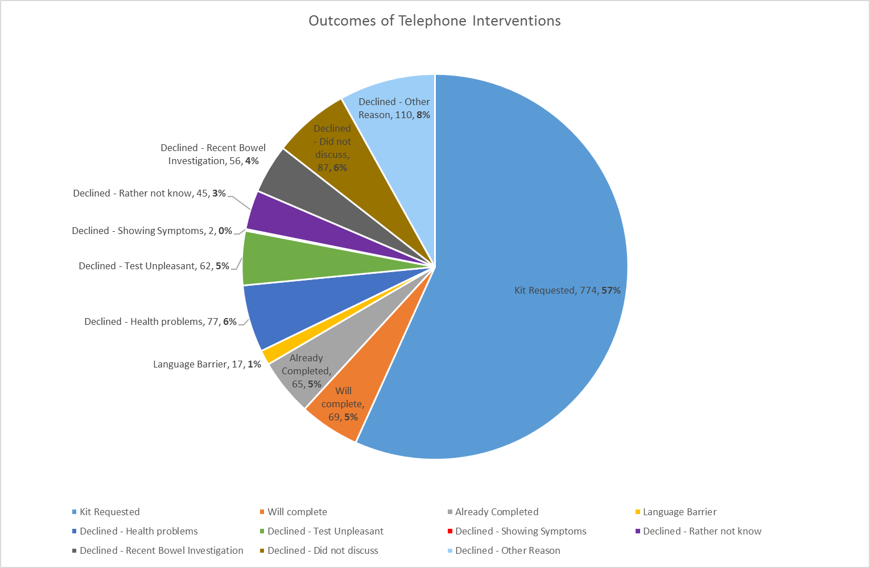

Appendix 2
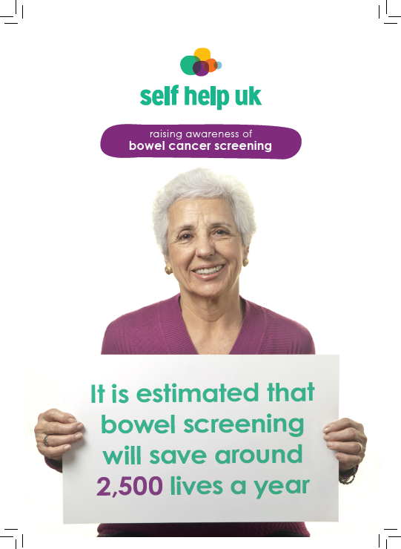
A5 double sided leaflet

Appendix 2
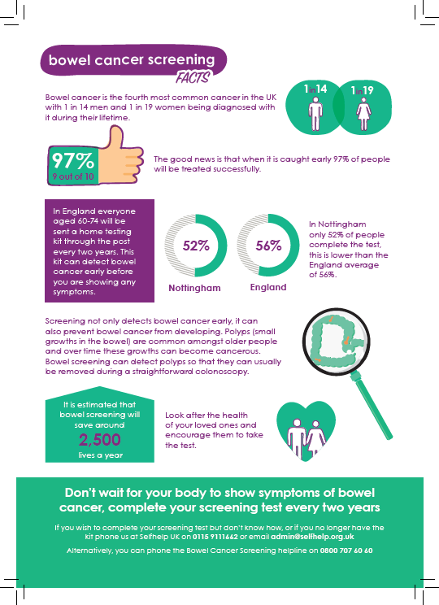
A5 double sided leaflet

Appendix 2
Poster Campaign

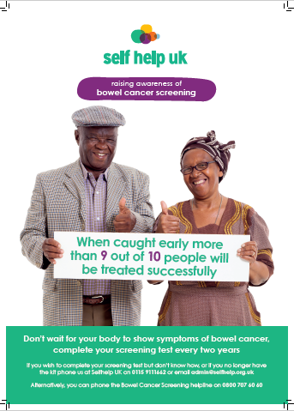
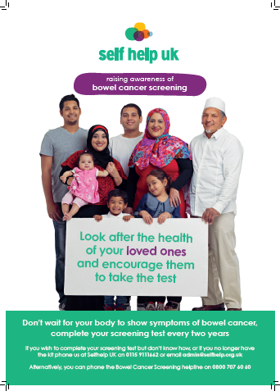

Appendix 2
Poster Campaign
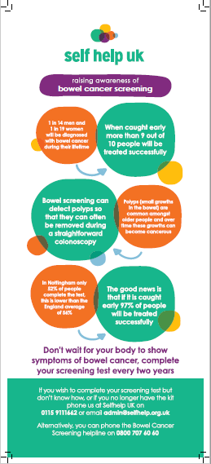
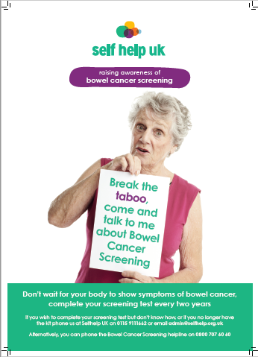

Appendix 3
Women’s Health Event Evaluation
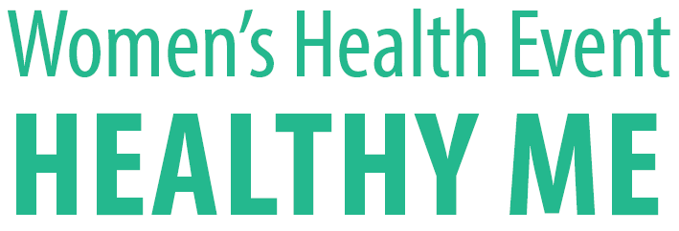

Event Report
The ‘Healthy Me’ women’s event held on the 27th April 2017 was a joint venture between Self help UK, the United Communities Network and the Hyson Green Cultural Festival. It was aimed at bringing information relating to health, Self help, education and employment to the women living in the Berridge, Arboretum, Radford and Park Wards. My aim was to hold the event during Bowel Cancer Awareness month to break down the taboo around bowel cancer and make the information more accessible. These wards were chosen owing to the fact that they are Super Output Areas with very low percentages of people completing their bowel cancer screening tests.
To make the event relevant and useful to the community we sought the opinions of a group of local women to see what services and activities they would like to know more about. The vast majority of women felt that they would benefit from knowing more about long-term health conditions and the services that were available to them. Most women also wanted support with CV writing and accessing employment or volunteering.
We chose to hold the event at The Vine Community Centre in Bobbersmill for its value for money, its central location to the targeted wards and the ideal size of the main hall.
When we initially started planning the event, we offered a stall to around 10 different organisations that we felt met the needs of the community. As word got around about the event, many other organisations approached us to ask for a until eventually we had to be selective with who we invited and had to turn several organisations away as there was not space to accommodate all. The organisations that held a stall or offered a service on the day were as follows:

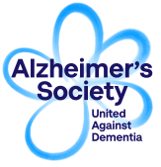 | Information and practical guidance to help people understand dementia, cope with day-to-day challenges and prepare for the future
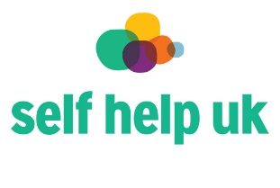  Beyond Diagnosis Service | In partnership with Macmillan the service provides practical and emotional support to people affected by cancer.
 | Provided a heart health information service including blood pressure checks
 | Bringing people together. We find creative solutions that help people find friendships, reconnect with their local community and do more of what makes them
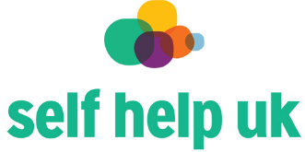 | Raising awareness of bowel cancer and promoting the importance of bowel cancer screening
 | An evidence based lifestyle weight management programme designed to help you manage your weight and live a healthier life.
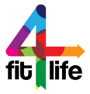 | A group of fitness "gurus" working across Nottingham to help adults with Type 2 Diabetes to achieve a healthier lifestyle
Information, reviews and news
about health and care services in Nottingham and Nottinghamshire

 | smoothie bike and tailored conversations about the importance of a healthy diet and exercise
 | Information and Support for people living, with or caring for a person with a cancer diagnosis
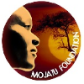 | A leading organisation in the global campaign to end Female Genital Mutilation (FGM)
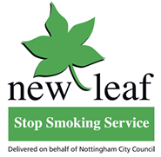 | Nottingham’s Local Smoking cessation service
 | NCC Leisure Centres provided information on the ‘This Girl Can’ initiative and a Zumba taster session
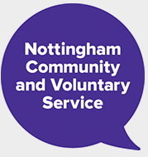 | Supports and develops voluntary action to benefit people in Nottingham
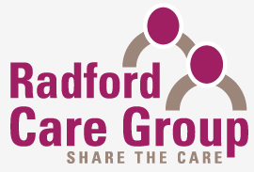 | local charity that has been providing innovative and invaluable support services to older people
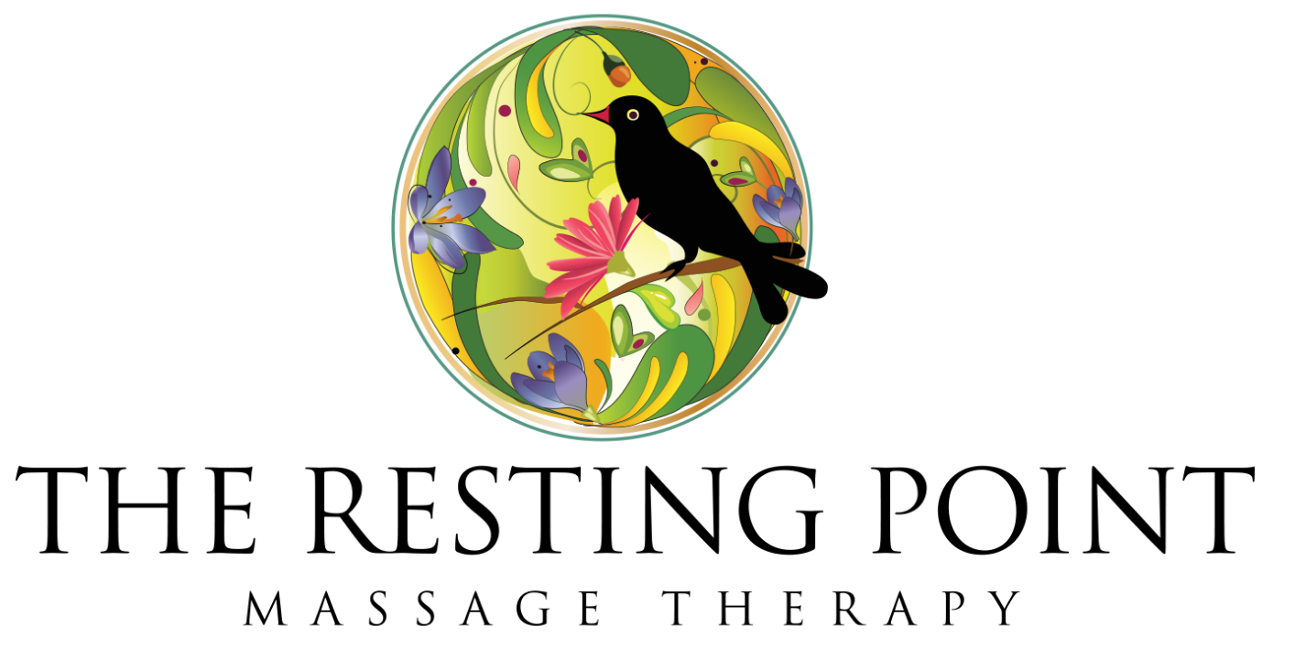 | The Resting Point offers a range of professional Massage Therapies dedicated to supporting and strengthening health and wellbeing in both body and mind
 | The national experts at supporting, growing and promoting a thriving self help community.
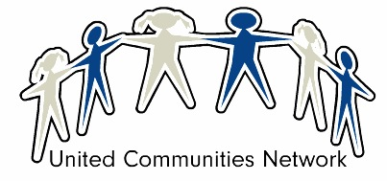 | Offers support to build skills of BME Women in the local community of Nottingham to overcome the barriers to training and employment
 | Offering female specific support to help women towards change and back into work

The event was advertised as part of Self help’s Bowel Cancer Awareness campaign on the local radio station Kemet FM, as well as poster advertising in local GP surgeries. United Communities Network’s Rukhsana Aziz also promoted the event on the BBC’s East Midlands Today programme. Social media was heavily utilised to spread the word via WhatsApp groups, Facebook and Twitter. We also had volunteers taking event posters to local shops, schools leisure centres etc. There was an expectation placed on each stallholder that they would advertise the event to their stakeholders/ patients/ service users etc. as well as advertising on their own social media. We had anticipated that there would be between 50 and 75 women attending the event, however due to a very successful advertising and promotion campaign there were well over 100 women in attendance on the day.

In order to attract women to the event we had several incentives on offer. These were advertised along with the event and included the following:
- Goody bag on arrival
- Free Indian Head Massage, Seated back neck and shoulders and hand Massage
- Mehndi hand art
- Children’s giveaways of colouring in flags and crayons and balloons
- Free Nottingham Leisure centre passes
- Free ride on the smoothie-making bike
- Raffle prizes including House of Frazer, Boots and Asda gift vouchers, Leisure centre goody bags and toiletry gift sets.
- Free Zumba taster sessions ran by NCC
- The Women’s Cultural Exchange also provided lunch on the day
The feedback we received repeatedly indicated that the free massage was a much-appreciated addition, as was the Zumba session.

The feedback we had collected prior to running the event indicated that may of the women were interested in getting into some form of exercise. This tied in well with our aim of promoting good bowel health. We invited Nottingham City Council leisure centres along to promote the national ‘This Girl Can’ campaign and raise awareness of their ‘women only’ exercise options. The feedback we received from NCC was that they had been surprised by how many women they had reached and signed up for sessions:
“We reached a lot of women who didn’t previously know about our This Girl Can swim programme”
As mentioned, during the event NCC staff ran a Zumba taster session. This was enjoyed by a wide variety of women of many different ages and fitness levels and the feedback suggests that it made people give extra consideration to exercise.

We also had Healthy Eating Solutions at the event offering a free ride on the smoothie-making bike. Again, this was promoting the importance of good bowel health in support of Bowel Cancer Awareness Month. The smoothie bike was enjoyed by lots of people, though not everyone completed their pedalling to make a smooth smoothie!

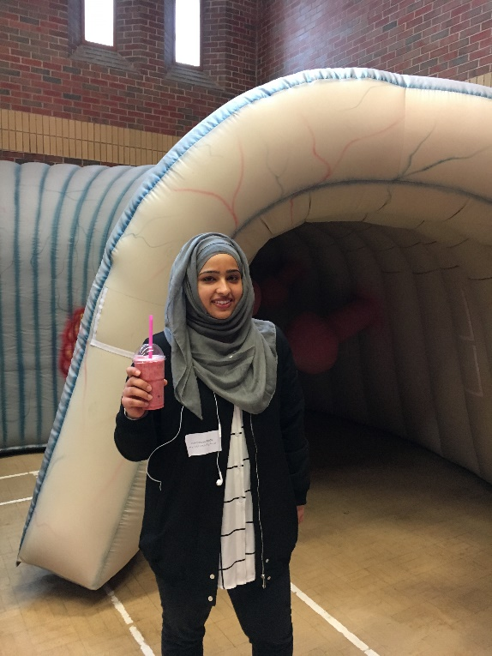
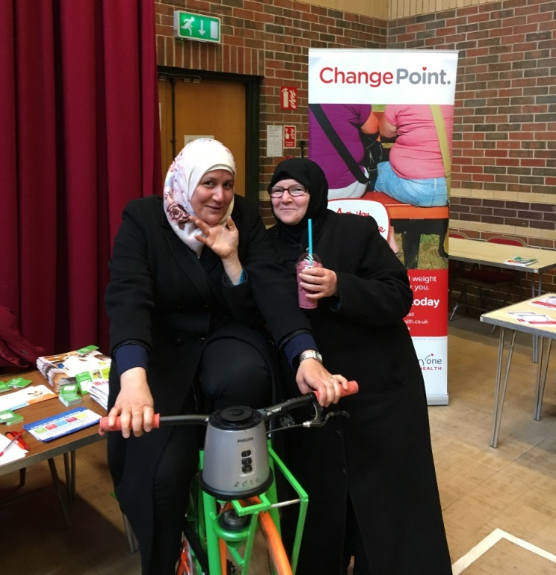

Throughout the event we also provided people with the opportunity of having their blood pressure and their BMI checked. The feedback we received from the women attending this event was that they found this very useful and there was certainly a lot of demand for both checks.

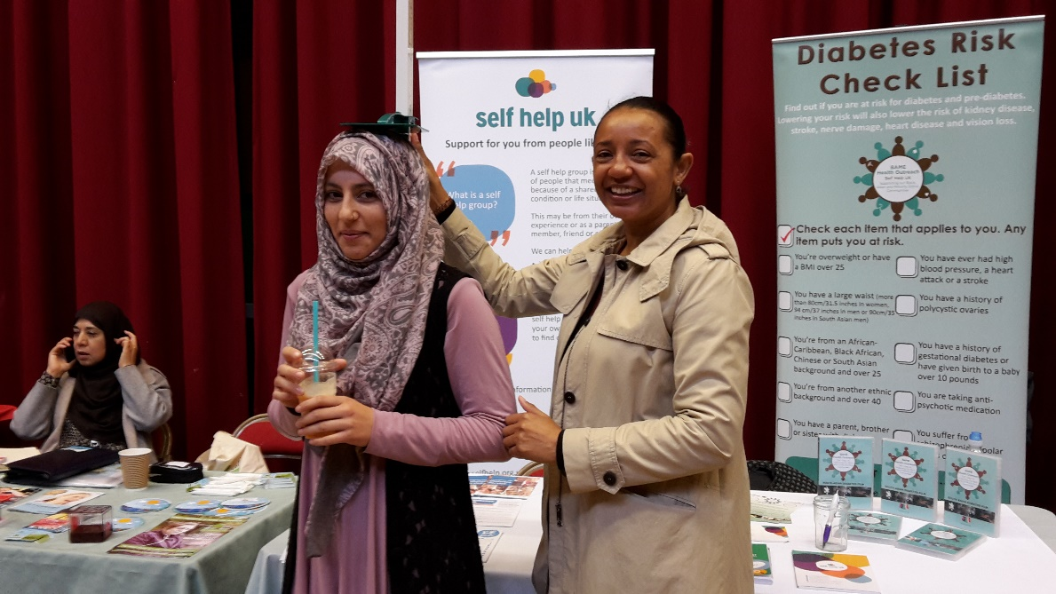
As part of the evaluation exercise one stallholder commented that:
“It was not only information, but testing on the day that got people involved and helped them to really start thinking about self-care, how long term health conditions can be prevented.”

We decided that, whilst many of the stalls offered information leaflets in various languages, this did not offer everyone the best opportunity to get the most from the event. In an attempt to bridge the gap caused by language barriers we had several volunteer interpreters at the event. These volunteers were clearly identifiable and happy to offer guided tours, one off interpreter discussion at individual stalls or interpret information about the running of the event. Both stall holders and attendees alike found this to be invaluable and many commented on it as part of their feedback:
“Having designated interpreters helped a lot”
“It allowed seldom heard groups to interact with services that can be of benefit to them.”

As part of the wellbeing element of the day, we had arranged for several services to be present to offer volunteering, education and employment opportunities. These services included the United Communities Network, the Beyond Diagnosis service, Nottingham Community and Voluntary Service, and the Nottingham Women’s Centre. The feedback we received from women attending the event highlighted how valuable this information was:
“It benefited me to much as I get the first opportunity to volunteering”
One stallholder commented that:
“We took details of about 5 people and are sending them information about volunteering at places that suit their skills and needs.”

Whilst only three requests were made for repeat bowel cancer screening tests, the inflatable bowel provided a much talked about addition to the event. Again, having interpreters present to speak to women to raise their awareness of what bowel cancer is and how to encourage themselves, family or friends to complete the test was an invaluable addition. Many women took leaflets home in a variety of languages to help spread the word, with some women posting on social media about the importance of screening.

In order for us to gain valuable evaluation of the event, attendees were given an evaluation form. In order to enter the prize draw women had to submit their completed evaluation forms and the prize draw was held at the end of the day. The prizes were very attractive and this meant that we had a lot more feedback than we would ordinarily have received.

Overall, the event proved to be a success. Whilst many people reported on how much fun they had had and how much they would love to attend again, the event helped to address the needs of the women in the community. Services felt that they had delivered their message and brought the information and available services to the community. The community felt much better informed about what help and support was available for a variety of long-term health conditions, physical and mental health needs and for their general wellbeing.

